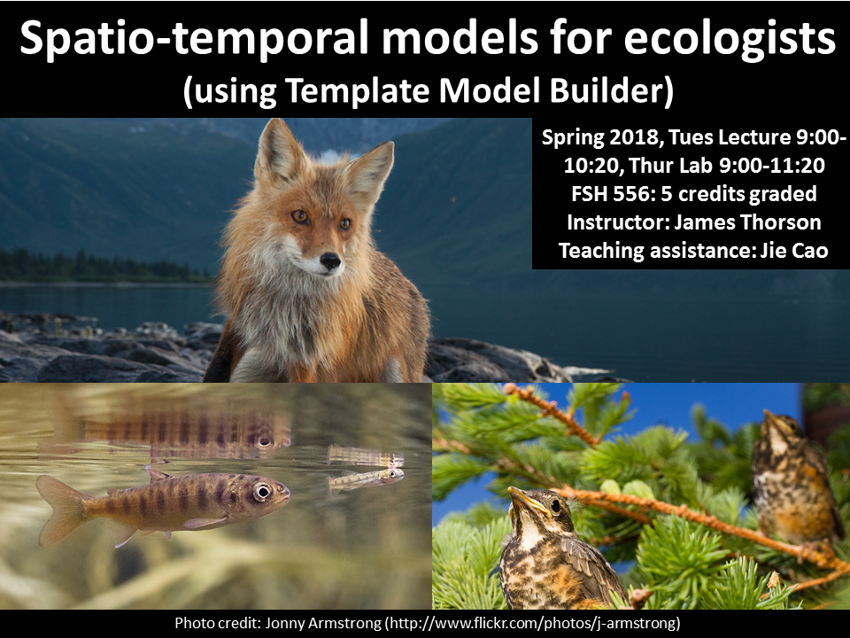

**Spatio-temporal models for ecologists**

**Instructors***:*

James Thorson

*Office Hours:*

Jim: Tues. after class

[JimThor@uw.edu](mailto:JimThor@uw.edu)

**Teaching Assistant**:

Jie Cao

[JieCao@uw.edu](mailto:JieCao@uw.edu)

**Spring 2018 Schedule**

Tues 9:00-10:20: Lecture

Thurs 9:00-11:20: Computer Lab

**Course size:** ~15 graduate students

**Credit hours:** 5

**COURSE BACKGROUND**

Ecology grew as a field to explain common spatial patterns in ecosystem structure and function. Since its birth, ecology has asked questions arising at broad spatial scales (e.g., why are some pairs of species not observed together in any island ecosystem). More recently, ecologists have developed statistical methods to separate signal (e.g., species competition in island communities) from random noise (e.g., null models for species co-occurrence). Therefore, there is continuing growth in methods and their interpretation to account for spatial patterns in both ecological processes and in unexplained noise. However, spatial statistical methods can seem intimidating without reliable tools for their development and a clear understanding of their interpretation and application.

**COURSE OBJECTIVES**

This course aims to develop applied skills for ecologists to understand, interpret, apply, and develop new models for spatial patterns in species and communities (whether marine, terrestrial, or human). In particular, students will learn to use a “mixed-effects models” which combine fixed effects (representing ecological relationships) and random effects (representing spatially structured errors). These mixed-effect models will then be used to develop models for spatial variation and how such variation can evolve over time. Students will develop these spatio-temporal models by progressively adding complexity to simple linear models. Throughout, the course will focus on a minimal toolbox to bridge between simple linear and complex spatio-temporal models. Students would be encouraged to develop an advanced understanding about the appropriate use of such approaches; namely, their correct application and their interpretation in natural sciences.

**LEARNING GOALS**

1. Apply understanding of statistical background for mixed-effects models, including statistical properties (consistency, bias, and estimating precision), when interpreting results from simulation experiments
2. Analyze spatial and spatio-temporal processes using descriptive tools including semi-variance, additive covariance functions, and separable covariance functions
3. Modify existing and create new code using R and Template Model Builder to implement linear and nonlinear mixed-effects models including spatial and temporal covariance.
4. Differentiate between the appropriate use of spatial and spatio-temporal modelling in the separation of process from spatially correlated noise.
5. Create new spatio-temporal models for use in simulation experiments, and analyze a real-world dataset of the students’ choosing.

**Pre-requisite knowledge**

We require the following experience prior to taking this class:

* Introductory knowledge of the R programming language (i.e., knowing how to open the software, save a script, perform basic arithmetic, and write a function)
  + Intro. to R programming (FISH 552), or equivalent experience
* Introductory knowledge to likelihood-based statistics (i.e., how to define a likelihood function, how to use a nonlinear optimizing function)
  + e.g., advanced R course (FISH 553), or FISH 454/458, or QSCI 451
* Intermediate background in statistical analysis (i.e., how to apply a new hierarchical model in a simulation experiment)
  + e.g., graduate-level applied analysis (FISH 558, or FISH 559, or SEFS 590), or applied statistics (STATS 516 or 517)

These skills should be acquired prior to beginning the course (i.e., students should have finished the courses above, and not be taking them concurrently). Students who are unsure whether they meet these requirements are invited to contact the instructor.

**Contacting Instructor**

Please post questions on the GitHub repository, so that answers to all questions can be searched and found by other students:

<https://github.com/James-Thorson/2016_Spatio-temporal_models/issues>

Please only send queries that can be answered by a short message. Questions that require more in-depth responses should be made in person during office hours (see above). The issue tracker will be checked daily, M – F. Generally, expect a response within 24 hours after it is checked.

**Lectures and laboratories**

Tuesday’s lecture is intended to introduce the biological, statistical and sampling theory necessary for a given topic, and will be accompanied by the assignment of a short homework. Thursday’s laboratories are intended to familiarize students with the modelling necessary for completing the four homework assignments.

**Readings**

Readings will be provided from the primary literature and made available prior to lectures. Readings are listed below in the syllabus.

**Homework**

Homework is assigned during Thursday labs, and is due at the beginning of the lab on the following week. You are required to write all code individually, even when working with assistance from other students. If collaborating, you are required to re-type all code individually (without using cut-paste, or file copying).

**Final project**

Part of the grade will be based on the final project. This grade includes:

1. a written description of the work plan in Week 5
2. a final presentation in Week 10; and
3. a written description of the research due finals week.

The project will require either simulated or real-world application of the methods from the class (or application of the hierarchical approach using other similar methods). Students are encouraged to replicate analyses in the published literature, or find data sets using Dryad (<http://datadryad.org/>) or Ecological Archives (<http://esapubs.org/archive/search.php>).

**Grading**

Your final grade will be based on the following:

Weekly homeworks in Weeks 1, 2, 3, and 5 (5 points each, 20 points total)

Written description of project topic and approach in Week 5 (5 points)

Final presentation of project (25 points)

Written description of project (50 points)

The following lists the minimum scores needed to achieve each grade tier.

|  |  |
| --- | --- |
| **Total points** | **Grade** |
| 90+ | 4.0 |
| 80-89 | 3.5 |
| 70-79 | 3.0 |
| 60-69 | 2.5 |
| 50-59 | 2.0 |
| 40-49 | 1.5 |
| 30-39 | 1.0 |
| 20-29 | 0.7 |

Graduate students must achieve a minimum of 3.0 to receive credit towards their degree.

Late written assignments are subject to a 1 pt./day penalty and will be assigned no credit after 7 days. Presentations must be done on the day assigned, and cannot be made up. **Holidays and weekend days are NOT excluded from the late penalty assignment**.

**Disability Accommodations**

It is crucial that all students in this class have access to the full range of learning experiences. At the University of Washington, it is the policy and practice to create inclusive and accessible learning environments consistent with federal and state law.

Full participation in this course requires the following types of engagement:

*Lecture and Laboratory*

the ability to attend weekly lectures of 50 minutes with 20 other students; the ability to interactive actively with instructor and students; the ability to bring and use a laptop to complete in-class programming activities

If you anticipate or experience barriers to your learning or full participation in this course based on a physical, learning, or mental health disability, please immediately contact the instructor to discuss possible accommodation(s).  A more complete description of the disability policy of the College of the Environment can be found [here](http://environment.uw.edu/intranet/academics/teaching/disability-accommodation/). If you have, or think you have, a temporary or permanent disability that impacts your participation in any course, please also contact Disability Resources for Students (DRS) at:  [206-543-8924](tel:206-543-8924) V / [206-543-8925](tel:206-543-8925) TDD / [uwdss@uw.edu](mailto:uwdss@u.washington.edu) e-mail / <http://www.uw.edu/students/drs>.

Roles and Responsibilities

*Student*: inform the instructor no later than the first week of the quarter of any accommodation(s) you will or may potentially require.

*Instructor and TA*: maintain strict confidentiality of any student’s disability and accommodation(s); help all students meet the learning objectives of this course.

### Academic Conduct Statement

At the University level, passing anyone else’s scholarly work (which can include written material, exam answers, graphics or other images, and even ideas) as your own, without proper attribution, is considered academic misconduct.

Plagiarism, cheating, and other misconduct are serious violations of the [University of Washington Student Conduct Code (WAC 478‐120)](http://www.washington.edu/students/handbook/conduct.html). We expect that you will know and follow university policies on cheating and plagiarism. Any suspected cases of academic misconduct will be handled according to university regulations. For more information, see the College of the Environment’s [Academic Misconduct Policy](http://environment.uw.edu/intranet/academics/academic-policies/academic-misconduct/) and the [Community Standards and Student Conduct website](http://www.washington.edu/cssc/).

**Draft syllabus**

Holidays: Memorial Day ()

* Week 1 (March 27/29) – Introduction to linear models and likelihood statistics
  + Objectives: Introduction to generalized linear models and Template Model Builder (TMB)
  + Lecture:
    - likelihood function
    - Hessian matrix and estimated standard error
    - nonlinear minimization
    - response and predictor variables
    - error distribution for response variables
  + Lab:
    - Theory of maximum likelihood estimators (consistency, bias, efficiency)
    - Setting up TMB
    - Comparison of TMB and functions in R for a zero-inflated gamma distribution
  + TMB skills:
    - Build TMB CPP file
    - Optimize in R
    - Extract standard errors
  + Homework:
    - Interpreting statistical inference in a simulation exercise evaluating statistical performance of zero-inflated Poisson GLM in TMB at estimating the parameter associated with a covariate
  + Assigned reading for next week
    - Zuur et al. 2010 <http://doi.org/10.1111/j.2041-210X.2009.00001.x>
* Week 2 () – Hierarchical models
  + Lecture:
    - Random effects
    - marginal likelihood function
    - Laplace approximation and inner vs. outer optimization
  + Lab:
    - Build a Poisson-GLMM
    - Comparison of TMB and *glmer* in R
  + TMB skills:
    - Implement random effects in TMB
  + Homework:
    - Code a Poisson-GLMM with repeated measures (i.e., an N-mixture model with site-level heterogeneity) using an example data set
  + Assigned reading for next week
    - Cressie et al. 2009 <http://doi.org/10.1890/07-0744.1>
* Week 3 () - Temporal structure and state-space models
  + Lecture
    - Build code for a Kalman filter
    - Compare with a loess smoother on simulated data
  + Lab
    - Modify Lecture 3 code to include autocorrelated error
  + Homework
    - Build a simulation exercise to explore the estimation performance of the lab model. Specifically, compile estimates from 100 replicates for 3 values of AR (-0.5,0,0.5) and three levels of measurement error (50% of process error, 100% of process error, 200% of process error)
  + TMB skills
    - Implement time-series structure in CPP code
  + Assigned reading for next week
    - Auger-Methe et al. 2017 <http://doi.org/10.3354/meps12019>
* Week 4 () – Multivariate state-space models
  + Lecture
    - Introduce covariance matrix
    - Cholesky and eigen-decomposition
    - Code to generate multivariate normal distribution
  + Lab
    - Build code for multivariate Kalman filter
  + Homework
    - 1-2 page written description of class project providing details on (a) the question to be addressed, (b) the data set to be used, and (c) the statistical analysis required to address this question
  + TMB skills
    - Use `map` feature in TMB to implement Cholesky decomposition
  + Assigned reading for next week
    - Dormann et al. 2007, <http://doi.org/10.1111/j.2007.0906-7590.05171.x>
* Week 5 () – Spatial analysis in TMB (1-dimension)
  + Lecture
    - Covariance for autocorrelated spatial process with equal distances in 1-dimension
    - Introduce discrete autoregressive and random-walk processes
    - Introduce sparseness of inverse-covariance
    - Role of sparseness in computation
  + Lab
    - Covariance for autocorrelated spatial process with unequal distances in 1-dimension
    - Introduce continuous Wiener and Ornstein-Uhlenbeck process
    - Build Poisson-GLMM for spatial variation with unequal sampling intervals
  + Homework
    - Modify lab code to include a covariate, and compare the coefficient associated with a covariate (and its estimated standard error) with and without AR process for an example data set
  + Assigned reading for next week
    - Bolker et al. 2009, <http://doi.org/https://doi.org/10.1016/j.tree.2008.10.008>
* Week 6 () – Spatial analysis in TMB (2-dimensions)
  + Lecture
    - Introduce “Species distribution models”
    - 2D AR process on uniform grid
    - Matern process with random locations in 2-dimensions
    - introduce Lindgren SPDE approximation
  + Lab
    - Introduce retransformation bias and bias-correction
    - Discuss “geometric anisotropy”
    - *In-class exercise*: compare different 2D estimates of total abundance for a spatial GLMM
  + Homework
    - No homework (work on project!)
  + Assigned reading for next week
    - Shelton et al. 2014, <http://doi.org/10.1139/cjfas-2013-0508>
* Week 7 () – Spatiotemporal models in TMB
  + Lecture
    - Combining spatial and temporal processes
    - Build code for ‘Spatial index standardization’
    - Discuss “advanced” distributions for continuous and discrete sampling data
  + Lab
    - *In-class exercise*: Build spatial Gompertz model using state-space parameterization (Matern spatial and AR temporal process)
  + Homework
    - 1-3 page summary of an R script that can simulate data similar to the data for your case study
  + Assigned reading for next week
    - Thorson et al. 2014, <http://doi.org/10.1890/14-0739.1>
* Week 8 () Spatial factor analysis
  + Lecture
    - Introduce factor models for estimating covariance among variables
    - Introduce spatial factor analysis
  + Lab
    - Introduce the R package VAST
    - Demonstrate using VAST for spatial factor analysis
  + Homework
    - No homework (work on project)
  + Assigned reading for next week
    - Thorson et al. 2015, <http://doi.org/10.1111/2041-210X.12359>
* Week 9 () Spatial dynamic factor analysis
  + Lecture
    - Introduce factor decomposition for spatial Gompertz model
  + Lab
    - Demonstrate using VAST for spatial dynamic factor analysis
  + Homework
    - Finish presentations (due starting week 9)
  + Assigned reading for next week
    - None.
* Week 10 () – Final project presentations
  + Homework
    - Finish 6-10 page project write-up (including all figures and tables, due finals week), incorporating at a minimum (a) an introduction, methods, results, and discussion section, (b) a clearly identified question, description of statistical method, and statistical support for answering the question
  + Assigned reading for next week
    - None.
* Week 11 – Final project presentations
* Finals week – Final presentations (if any remain)